*${Slogan}*

**${Phone}**

${Website}

${Email}

**${Name}**

##### Wondering what your home is worth?

Get a FREE market report, comparing your home to similar homes that have recently sold. I’ll add information about the trend of home prices in your area. Text **VALUE + *your address*** to   
**${Phone}**

### 

**August Quiz Question**

*With me, you can see cities but no houses, mountains but no rocks, and coasts but no sand. What am I?*

Have you seen those signs that say, "I buy ugly houses"? I have, and that makes me wonder, what is an UGLY house?

I know someone who thinks her house is ugly. It's a box (literally called a Salt Box style) with a pretty garden. To me it's quaint and comfortable looking. Not ugly at all. I asked her what's ugly about it, and she pointed out the plainness of the architecture.

I looked up the website of the person with the "I buy ugly houses" signs. He said an ugly house has structural problems, or is in a high-crime area, or is in obvious disrepair. But I've seen some beautiful homes that have those problems, so his use of "ugly" is more for marketing purposes than a descriptor. (I think the house pictured above has pretty bones...imagine it all fixed up!)

If you watch house-hunter shows, you will often see couples disagreeing about what they each think is ugly or attractive in a home. Those disagreements are staged, but as a Realtor, I've often encountered the same disagreements in real life.

Most of us are attracted or repelled by a home based on a whole raft of past experiences. Our parent's home was built in the 1970s so we want a modern home. As we get older, we want a home that looks more like it was built in the 1970s because it feels like home. You might have noticed your own tastes changing over the years. **I wonder if there's a house that everyone would agree is ugly?** Beauty is in the eye of the beholder.

#### Here's why the price of gas always ends in 9/10 of a cent

No other retailers advertise prices in fractions of a cent. The practice first appeared in the early 20th century in the US as a sales tax on gas to help build highways. At the time, taxes were levied in tenths of a cent and gas stations passed that on to drivers. The practice continued in the US and Canada when gas companies realized that psychologically, consumers would see the main number and not the tenths. That would allow companies to get away with charging an extra tenth of a cent.

#### I work hard to earn your Endorsement & Referrals. Thank you for telling your friends about me.

*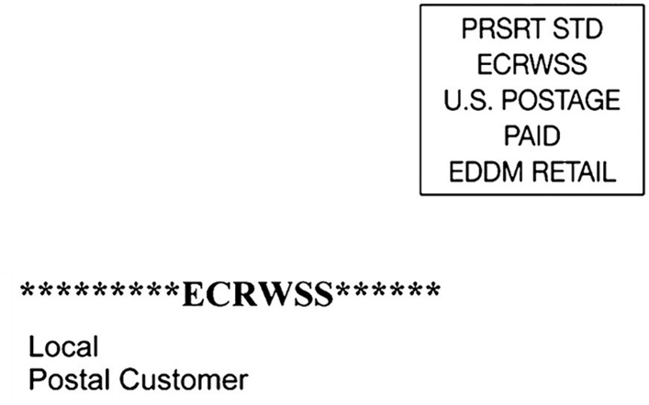**

##### Free Report

### Buyers Are ARMing Themselves

With rates rising and home prices   
still high, many home buyers are   
turning to adjustable-rate mortgages (ARM) instead of fixed rate loans. **Here are 4 benefits to using an ARM to buy in today’s real estate market.**

## Are Lifestraws Really Safe to Drink from?

They're a popular item for hikers and campers this summer, but do they really provide clean drinking water? Park officials say “point-of-use” water filters, like those often found in water bottles or Lifestraws, won’t remove norovirus; any water you grab from a stream or lake should also be chemically disinfected or boiled.

You can boil water for at least one minute or at least three minutes if you are above 6,500 feet.

Or you can use iodine or chlorine drops, then wait 20 minutes for the bacteria to be killed off.

## Advice from Buyers for AFTER Moving into Your New Home

1. “Good fences make good neighbors.” Respect your neighbors’ values by keeping your own property neat and secure. They’ll like you more.
2. If you see something you want to change about the home’s structure, don't wait too long. You’ll get used to it and then spend the next several years wishing you’d changed it.
3. "Measure twice, cut once," as the saying goes. When doing DIY, my advice is to measure thrice, then get a second opinion before cutting.
4. When decorating, don’t leave the curtains if you hate them!
5. "A place for everything, and everything in its place.” When you first put things in a place, they tend to stay there. Place with awareness.
6. Never buy furniture online that you haven't tried. Self-explanatory.
7. Tell everyone about the awesome experience you had with your Realtor (me).

*This newsletter is for entertainment purposes only. Credit is given to the authors of articles that are reprinted when the original author is known. This information is solely for entertainment, and should not be substituted for medical, legal, financial or tax advice. Do not hold us responsible for actions you take without proper medical, financial, legal or tax advice. This is not intended as a solicitation of listed property.*

**${Name}**

**${Phone}**

**${Email}**

### Win a FREE Gift Card

It’s easy to play! Email me your answer to the question on **page 1**.

* **Last month's Q&A:** ***How many bananas can you eat if your stomach is empty? Just one, then your stomach isn’t empty.***

Congrats to last month’s winner! **${Contest Winner}**

**To Insert Your Picture**

1. **RIGHT CLICK** on the placeholder image.
2. From the floating menu, choose **Change Picture**.
3. **Find and insert** your image from your computer.
4. **Resize and position** your image using your mouse. (Use the **Crop feature** on the Shape Format menu to crop.)

See how to work with images inside text boxes in Word: <https://www.youtube.com/watch?v=lKs8-1USlR4>