*${Slogan}*

**${Phone}**

${Website}

${Email}

**${Name}**

### 

##### Need to know what your home is worth?

**Get a FREE price estimate!**

This can help you decide if you want to refinance, grab a home equity line, or sell while prices are still up.

Text **VALUE + your address** to me.

${Phone}

# Where in the World?

Can you guess which country these 10 iconic house styles belong to? Jot your guess on the line, then see the answers below. (Cover the bottom if you want to make sure you can’t see the answers until you’re ready.)

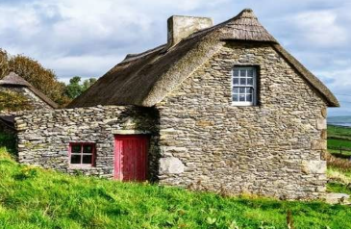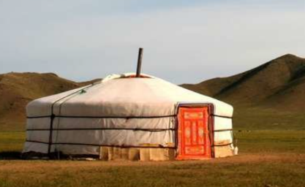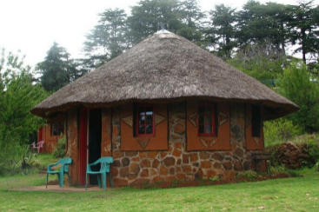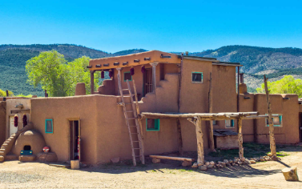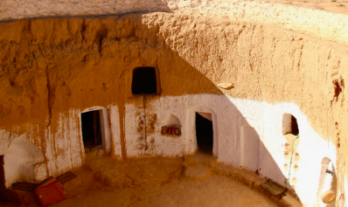

**3**

**4**

**5**

**6**

**7**

**8**

1 ________

2 ________

3 ________

4 ________

5 ________

6 ________

7 ________

8 ________

9 ________

10 _______



**1**

**2**

**9**

**10**

#### September Quiz Question

*You bought an item for $7, sold it for $8, bought it back for $9, and sold it for $10. How much profit did you make?*

#### Is it more expensive to run an EV than a gas car?

Fully electric vehicles (EV) are more expensive to buy, but they’re cheaper to run. Or are they?

When it comes to a pure kilowatt to gas comparison, EVs win, hands down.

But other factors can complicate the economics of EV ownership, such as the higher initial price of an EV, the cost of your home charger, electricity costs, state fees to offset the loss of gas tax revenue, and time costs as you hunt for a charging station.

Ultimately, EVs are less expensive to drive daily and better for clean skies, but they might not always be as economical as we expect.



### Done with house-hunting on the computer? Call to start house-hunting in person. ${Phone}

## Financial Therapy Is a Big Deal

Worry about financial matters can have a crippling effect on people, negatively impacting their family life, work, and all other aspects of their lives. Financial therapy is counseling that combines financial advice and emotional support. For details about using this kind of counseling, and to find a certified financial therapist near you, search “**Financial Therapist.**”

#### Are Open Houses a Waste of Time?

With an increasing number of homes on the market, many real estate agents are asking sellers to approve holding open houses. Do they work? Read this short explanation and decide for yourself.

Use your QR app to read now, or text me for a copy.

**One Monthly**

#### Slide this Alternative Article Over…

***If you don’t need the mailing label area***, you can slide this article over to cover the center panel. You can also delete the text inside the box and type your own article here.

To slide the article, click the edge of the article box. Then hold your mouse button down as you move it.

**Delete any box (including this yellow box) by clicking on the edge of the box, then clicking delete on your keyboard.**

${Name}

${Company Name}

${Company Address}

${City - State or Province - Postal Code}

${License}

## Dr. Seuss' Mid-Century Home for Sale for the First Time Since Built

Can you sell it in a box? Can you sell it with a fox? The Theodor Suess Geisel home hit the market in August for the first time ever. We don't yet know the selling price, but the asking price was nearly $19 million. There’s a great story about the history of the house online. Search: “**nbcsandiego dr seuss house for sale**” to find it.



**To Insert Your Picture/logo**

1. **RIGHT CLICK** on the placeholder image.
2. From the floating menu, choose **Change Picture**.
3. **Find and insert** your image from your computer.
4. **Resize and position** your image using your mouse. (Use the **Crop feature** on the Shape Format menu to crop.)

See how to work with images inside text boxes in Word: <https://www.youtube.com/watch?v=lKs8-1USlR4>

##### Thank you!

My clients and friends are an important and *appreciated* part of my business. I do my best because of the support I get from people like you. Special thanks this month to…

**${Thank You Box - Name 1}**

**${Thank You Box - Name 2}**

**${Thank You Box - Name 3}**

# WIN A $5 COFFEE CARD

To play, email me the answer to the question on **page 1**. Put the word **QUIZ** in the subject line. **${Email}**

* **Last month's Q&A:** ***With me, you can see cities but no houses, mountains but no rocks, and coasts but no sand. What am I? A map.***

Congrats to last month’s winner!   
**${Contest Winner}**

**${Name}**

**${Phone}**

**${Email}**

*This newsletter is for entertainment purposes only. Credit is given to authors of articles that are reprinted when the original author is known. This information is solely for entertainment, and should not be substituted for medical, legal, financial or tax advice. This is not intended as a solicitation of listed property.*