*${Slogan}*

**${Phone}**

${Website}

${Email}

**${Name}**

### 

##### Need to know what your home is worth?

**Get a FREE price estimate!**

This can help you decide if you want to refinance, grab a home equity line, or sell while prices are still up.

Text **value + your address** to me.

${Phone}

# Where in the World?

Can you guess which country these 10 iconic house styles belong to? Jot your guess on the line, then see the answers below. (Cover the bottom if you want to make sure you can’t see the answers until you’re ready.)

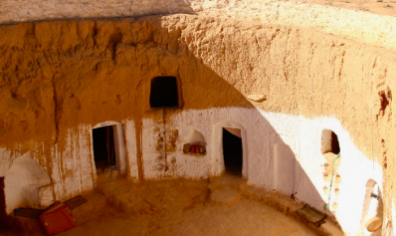

**3**

**4**

**5**

**6**

**7**

**8**

1 ________

2 ________

3 ________

4 ________

5 ________

6 ________

7 ________

8 ________

9 ________

10 _______



**1**

**2**

**9**

**10**

#### Is it more expensive to run an EV than a gas car?

Fully electric vehicles (EV) are more expensive to buy, but they’re cheaper to run. Or are they?

When it comes to a pure kilowatt to gas comparison, EVs win, hands down. But other factors can complicate the economics of EV ownership, such as the higher initial price of an EV, the cost of your home charger, electricity costs, state fees to offset the loss of gas tax revenue, and time costs as you hunt for a charging station.

Ultimately, EVs are less expensive to drive daily and better for clean skies, but they might not always be as economical as we expect.





### Done with house-hunting on the computer? Call to start house-hunting in person. ${Phone}



# How to shop for a mortgage without hurting your credit

If you’ll be applying for a mortgage soon, take these extra steps to ensure your credit score doesn’t take a hit through the homebuying process.

* **First**, avoid establishing any additional credit while applying for a mortgage and for the entire time you're in the home buying process, until closing. That means no car purchases, appliances, or even in-store credit cards. Use the credit you have and pay it off immediately.
* **Second**, select one or two mortgage companies who will do a *pre-qualification* for you. Resist their efforts to have your credit pulled at this point. The details of a pre-qualification are based only on what you tell the lender, so you can see it won't be official. But the process can give you knowledge for comparing lenders and can help you know if you need to do more financial work before formally applying for a mortgage. Some lenders won't do a pre-qualification for you without pulling credit. If not, go to the next lender.
* **Third**, when you’re ready, fill out a formal mortgage application with two or three different companies, including a hard credit pull. If you do this ***within 45 days of each other***, it won’t be counted against your credit report, because mortgage companies expect you to compare. You might want to compare different types of lenders, not simply different companies. There are mortgage brokers, bank lenders, and online mortgage companies. Perhaps select one of each for a full spectrum of variety. Since you only have 45 days in the credit grace period, it pays to have done your homework during your pre-qualification phase. **Let me know if you need referrals to lenders.**

# September Quiz Question

*“You have to be odd to be number one.”*

*~ Theodor Geisel*

*You bought an item for $7, sold it for $8, bought it back for $9, and sold it for $10. How much profit did you make?*

## Dr. Seuss' Mid-Century Home for Sale for the First Time Since Built

Can you sell it in a box? Can you sell it with a fox? The Theodor Suess Geisel home hit the market in August for the first time ever. We don't yet know the selling price, but the asking price was nearly $19 million. There’s a great story about the history of the house online. Search: “**nbcsandiego dr seuss house for sale**” to find it.



# Quiz Contest - Win a FREE Coffee Card

Email me the answer to the question on **page 2**. Put the word **QUIZ** in the subject line. **${Email}**

* **Last month's Q&A: *With me, you can see cities but no houses, mountains but no rocks, and coasts but no sand.   
  What am I? A map.***

Congratulations to last month’s winner!

**${Contest Winner}**

##### Thank you!

You have been an appreciated part of my business. I couldn’t do my best without you. Special thanks to…

**${Thank You Box - Name 1}**

**${Thank You Box - Name 2}**

**${Thank You Box - Name 3}**

**September 2022 ${Name} | ${Phone}**



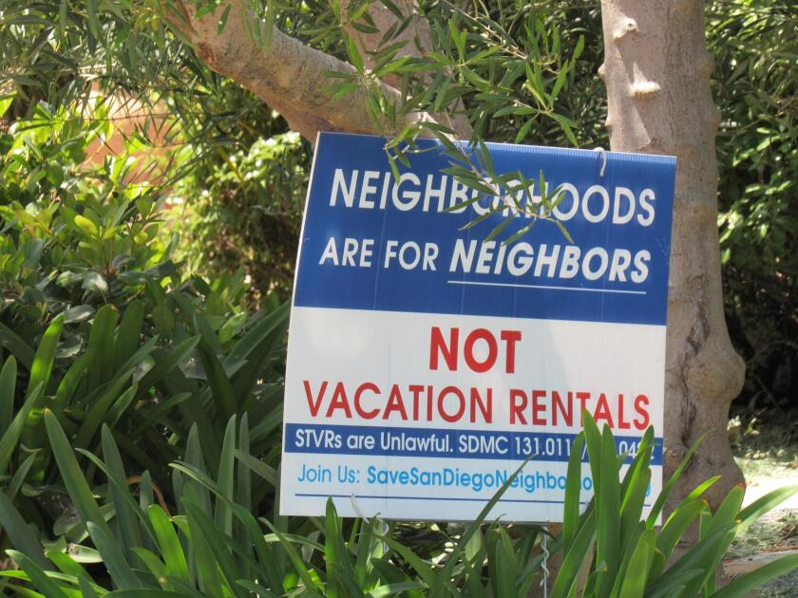

# The Ongoing War between Short- and Long-Term Rentals

A few months ago, I wrote about efforts just about everywhere to clamp down on short term rentals in an order to increase the availability of long-term rentals for locals who need a place to live.

The problem is more severe in destination locations, such as the popular red rock wonderland of Sedona, Arizona, where the city has recently approved offering $10,000 incentives to some homeowners if they agree to rent their homes only to long-term renters.

There is no simple solution to the rental issue that pleases everybody. People need a place to live, but no one wants the government telling them what they can do with their homes. This feels like a local-level problem to be solved on a community basis. I applaud the creative thinking that went into the Sedona solution. It's pro-owner and pro-renter. I wonder if it will work.

Other solutions include incentives to build mother-in-law apartments in exchange for making them long term rentals, community involvement in affordable housing design to address NIMBYISM, and revitalizing low-income neighborhoods to make them more desirable rental communities.

## Financial Therapy Is a Big Deal

Financial therapy is counseling that combines financial advice and emotional support to help people manage financial stress. Worry about money and financial matters can have a crippling effect on people, negatively impacting their family life, work, and all other aspects of their lives. For details about using this kind of counseling, and to find a certified financial therapist near you, do a Google search for “**Financial Therapist**”.

##### Free Report

#### Are Open Houses a Waste of Time?

With an increasing number of homes on the market, many real estate agents are asking sellers to approve holding open houses. Do they work? Read this short explanation and decide for yourself.

Use your QR app to read now, or text me for a copy.

**One Monthly**

${Name}

${Company Name}

${Company Address}

${City - State or Province - Postal Code}

${License}

This newsletter is for entertainment purposes only. Credit is given to the authors of articles that are reprinted when the original author is known. This information is solely for entertainment, and should not be substituted for medical, legal, financial or tax advice. Do not hold us responsible for actions you take without proper medical, financial, legal or tax advice. This is not intended as a solicitation of listed property.

#### Upper Panel Instructions

**1. You can use this area for mailing labels.** See the image for the correct way to fold and tab your newsletters on Tabloid paper. Seal all the edges using tabs. ([Printing Tutorial](https://www.youtube.com/watch?v=1xCnGD4F304) – **Control + Click** to view.)

**2. You can use this area for content.** If you don’t plan to mail the newsletters as self-mailers, then you can add your own content to this area instead of labels. First delete the back page title and return address.

**To delete the yellow instruction boxes, click on   
an edge of the yellow box, then click DELETE on your keyboard.**



## Is it wise to use home equity to remodel?

If you're one of the lucky ones who purchased a home prior to the recent real estate price spike, then you may be dreaming about using your home equity to remodel. When is and isn't that a wise idea? Unfortunately, there isn't a simple answer. Here are some of the parameters to consider:

**First**, there are different ways to tap your equity, with differing costs and tax consequences, including a line of credit, refinancing, or getting a second mortgage. You’ll want to talk with your tax advisor about these options. **Next**, factor in how many years you have left to pay on your primary mortgage, and your exit plans. That is, when will you sell/retire, etc. **Third,** factor in the potential loss of equity…if you plan to sell in five years, it’s possible the market may have fallen below your combined mortgage and home equity loan. You may decide to take a smaller equity loan to be on the safe side.

On the other hand, if your home is in poor condition or suffers from obsolete functionality, then remodeling can add value to your life as well as your property. **Contact me for a before and after home price valuation to help you make that decision.**



**To Insert Your Picture/logo**

1. **RIGHT CLICK** on the placeholder image.
2. From the floating menu, choose **Change Picture**.
3. **Find and insert** your image from your computer.
4. **Resize and position** your image using your mouse. (Use the **Crop feature** on the Shape Format menu to crop.)

See how to work with images inside text boxes in Word: <https://www.youtube.com/watch?v=lKs8-1USlR4>

**${Name}**

**${Phone}**

**${Email}**