**FRONT PORCH NEWS**

### 

${Name} | **${Phone}** | ${Website}

##### Need to know what your home is worth?

**Get a FREE price estimate!**

This can help you decide if you want to refinance, grab a home equity line, or sell while prices are still up.

Text **VALUE + your address** to me.

${Phone}

# Where in the World?

Can you guess which country these 10 iconic house styles belong to? Jot your guess on the line, then see the answers below. (Cover the bottom if you want to make sure you can’t see the answers until you’re ready.)

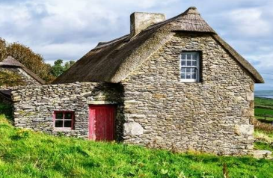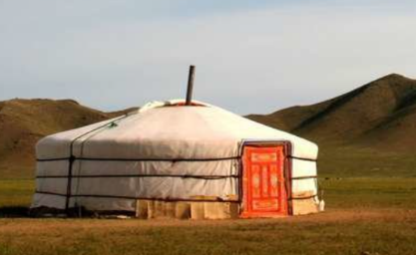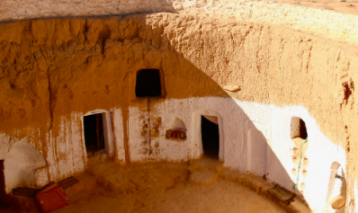

**3**

**4**

**5**

**6**

**7**

**8**

1 ________

2 ________

3 ________

4 ________

5 ________

6 ________

7 ________

8 ________

9 ________

10 _______



**1**

**2**

**9**

**10**

#### September Quiz Question

*You bought an item for $7, sold it for $8, bought it back for $9, and sold it for $10. How much profit did you make?*

#### Is it more expensive to run an EV than a gas car?

Fully electric vehicles (EV) are more expensive to buy, but they’re cheaper to run. Or are they?

When it comes to a pure kilowatt to gas comparison, EVs win, hands down.

But other factors can complicate the economics of EV ownership, such as the higher initial price of an EV, the cost of your home charger, electricity costs, state fees to offset the loss of gas tax revenue, and time costs as you hunt for a charging station.

Ultimately, EVs are less expensive to drive daily and better for clean skies, but they might not always be as economical as we expect.



### Done with house-hunting on the computer? Call to start house-hunting in person. ${Phone}

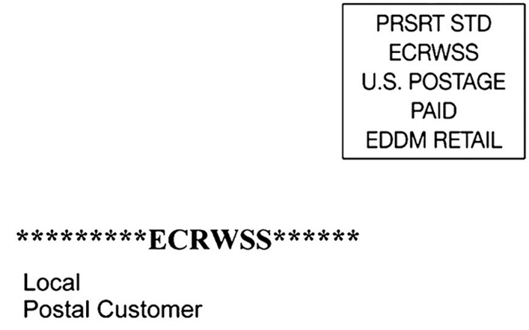

# How to shop for a mortgage without hurting your credit

* **First**, avoid establishing any additional credit while applying for a mortgage and for the entire time you're in the home buying process, until closing. That means no car purchases, appliances, or even in-store credit cards.
* **Second**, select one or two mortgage companies who will do a *pre-qualification* for you. Resist their efforts to have your credit pulled at this point. The details of a pre-qualification are based only on what you tell the lender, so you can see it won't be official. But the process can give you knowledge for comparing lenders and can help you know if you need to do more financial work before formally applying for a mortgage.
* **Third**, when you’re ready, fill out a formal mortgage application with two or three different companies, including a hard credit pull. If you do this ***within 45 days of each other***, it won’t be counted against your credit report, because mortgage companies expect you to compare. Since you only have 45 days in the credit grace period, it pays to do your homework during pre-qualification. **Let me know if you need referrals to lenders.**

##### Free Report

With an increasing number of homes on the market, real estate agents are again asking sellers to approve open houses. Do they work? Read this and decide for yourself.

## Financial Therapy Is a Big Deal

Worry about financial matters can have a crippling effect on people, negatively impacting their family life, work, and all other aspects of their lives.

Financial therapy is counseling that combines financial advice and emotional support. For details about using this kind of counseling, and to find a certified financial therapist near you, search “Financial Therapist.”

**To Insert Your Picture/logo**

1. **RIGHT CLICK** on the placeholder image.
2. From the floating menu, choose **Change Picture**.
3. **Find and insert** your image from your computer.
4. **Resize and position** your image using your mouse. (Use the **Crop feature** on the Shape Format menu to crop.)

See how to work with images inside text boxes in Word: <https://www.youtube.com/watch?v=lKs8-1USlR4>

**${Name}**

**${Phone}**

**${Email}**

* **Last month's Q&A:** ***With me, you can see cities but no houses, mountains but no rocks, and coasts but no sand. What am I? A map.***

Congrats to last month’s winner! **${Contest Winner}**

### Win a FREE Gift Card

It’s easy to play! Email me your answer to the question on **page 1**.

*This newsletter is for entertainment purposes only. Credit is given to the authors of articles that are reprinted when the original author is known. This information is solely for entertainment, and should not be substituted for medical, legal, financial or tax advice. Do not hold us responsible for actions you take without proper medical, financial, legal or tax advice. This is not intended as a solicitation of listed property.*